Authorization protocols on VPNs
Introduction
Previously you were introduced to the fundamentals of both authentication and authorization. You learned how authentication and authorization can be used to allow only authorized users to access specific data and resources on your servers. In this reading, you will explore the benefits of using VPNs in access control systems and the different protocols they use.
To begin, access control systems are essential for ensuring that only authorized users can access sensitive data and resources. VPNs (Virtual Private Networks) are commonly used in access control systems to provide secure and private access to network resources.
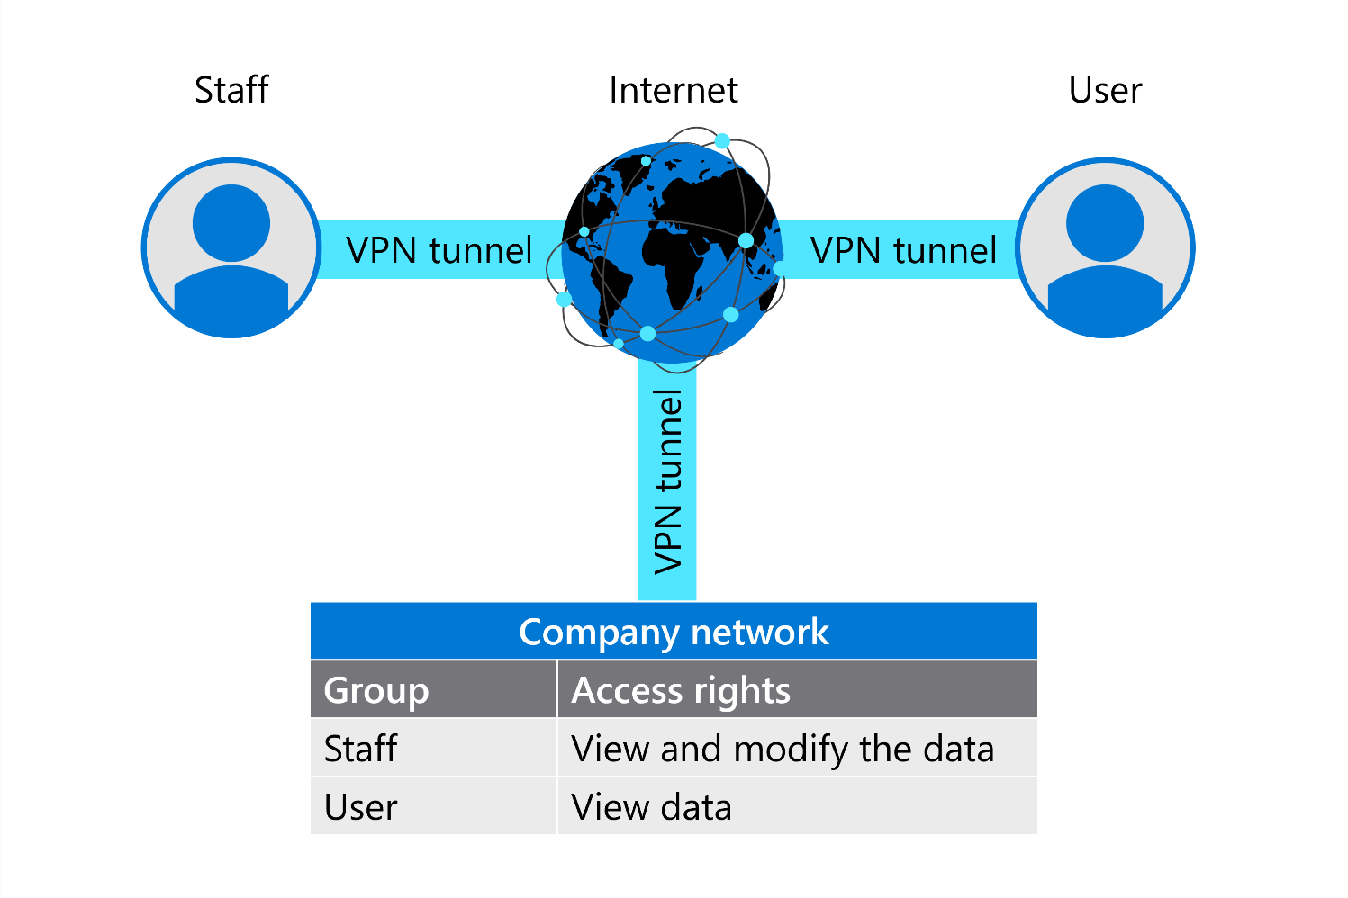
How VPN helps in access control system
By now you know that VPNs provide a secure and private connection between two devices over the internet. VPNs use encryption and authentication for internet traffic, making it difficult for third parties to intercept or eavesdrop on the traffic.
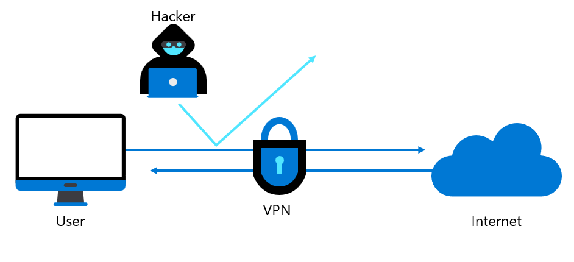
VPNs also enable remote access to network resources, providing a secure and efficient way for users to access sensitive data and resources from outside the organization's network. Using VPNs in access control systems provides several benefits, including:
Secure remote access: Earlier you learned that VPNs allow users to access network resources from anywhere in the world, regardless of their location, using a secure and private connection over the internet. This is particularly important in today's business environment, where remote work is becoming increasingly common. By using VPNs for remote access, organizations can provide their employees with the flexibility to work from anywhere while ensuring that sensitive data and resources are protected from cyber threats and unauthorized access.
Protection of sensitive data: VPNs use encryption to protect the data from being intercepted or read by third parties, while authentication mechanisms verify the identity of users to ensure that only authorized users can access the VPN. VPNs also use data integrity checks to ensure that the data was not tampered with during transmission and secure tunneling to create a private connection between the user's device and the VPN server.
Granular control over access control: Granular control refers to the ability to define precise and specific access control policies for individual users or groups of users. It enables organizations to control access to resources on a fine-grained level, ensuring that users only have access to the resources they need to perform their job functions. VPNs enable administrators to define detailed access control policies based on user identity, group membership, location, time of day, and other criteria. Without granular control, it may be difficult to ensure that only authorized users are accessing these resources, increasing the risk of data breaches, cyberattacks, and other security incidents.
Compliance with regulatory requirements: VPNs can also help organizations comply with regulatory requirements for data protection and security. For example, some regulations may require organizations to encrypt all data transmissions, including remote access connections. By using a VPN, organizations can ensure that all remote access connections are encrypted, regardless of the location of the user.
Different types of authorization protocols used by VPNs
You’ll remember that at the start of this lesson, you were introduced to authorization protocols for VPNs and learned how they play a critical role in enforcing access control policies. You were introduced to some of the common protocols used, including RADIUS and LDAP.
You discovered how Remote Authentication Dial-In User Service (RADIUS) is an authentication protocol that uses a centralized server to authenticate and authorize users. You also learned how RADIUS provides a way to manage network access by controlling who is allowed to access the network and what they can access. Further to this, RADIUS servers can also provide accounting services, which track user access to network resources and generate reports for billing or auditing purposes.
You also explored Lightweight Directory Access Protocol (LDAP) and discovered how it’s a directory service that provides a way to store and retrieve information about network resources and users. LDAP is often used to manage authentication and user permissions and access control policies, ensuring that only authorized users can access network resources. This is done against a directory service, such as Microsoft Active Directory or OpenLDAP, providing a centralized database of user credentials and access rights.
One protocol that was not covered earlier is Terminal Access Controller Access Control System Plus (TACACS+). This is a security protocol that provides centralized authentication, authorization, and accounting services. TACACS+ separates the authentication, authorization, and accounting functions, allowing for more granular control over access to network resources.
The tables below shows both the advantages and disadvantages of RADIUS, LDAP, and TACACS+.
Radius
Pros | Cons
Centralized authentication and authorization | Limited support for complex access control policies
Provides accounting services
Can be integrated with various VPN solutions
LDAP
Pros | Cons
The hierarchical directory structure for managing user accounts and permissions | LDAP servers can be complex to manage
Can be integrated with VPN solutions for user authentication | Limited support for accounting services
Provides a centralized directory for managing user accounts
TACACS+
Pros | Cons
Provides a separate authentication and authorization process for each network device | Can be complex to configure and manage
Enables administrators to set different access control policies for each device | Limited support for centralized authentication and authorization
Can provide accounting services for network devices
Traffic auditing and preventing VPN misuse
As you discovered earlier, authorization is an ongoing process that requires auditing. This is the process of monitoring and recording activities related to access control. It involves keeping track of who has accessed what resources and when. It monitors what actions they have taken whilst accessing those resources.
The purpose of auditing is to create an audit trail that can be used to:
- Further investigate security incidents
- Identify potential security breaches
- Ensure compliance with regulations and policies
Preventing VPNs from being misused is also a very important part of keeping your organization safe and secure. You can implement the following steps besides normal authentication and authorization to stop the VPNs from being abused.
- Unusual VPN activity: Be vigilant and watch for any unusual VPN activity, such as an unusually high number of connections or data transfer.
- Suspicious login attempts: If there are repeated login attempts using incorrect credentials or from unknown IP addresses, it could be a sign of VPN misuse.
- Change in user behavior: If a user's behavior suddenly changes, such as working unusual hours or accessing unusual websites, it could be a sign of VPN misuse.
- Accessing sensitive information: If a user is accessing or trying to access sensitive information that they shouldn't have access to, it could be a sign of VPN misuse.
- Inconsistent geolocation: If a user's geolocation changes frequently or they are accessing the VPN from an unusual location, it could be a sign of VPN misuse.
- Unusual network traffic: If there is unusual network traffic, such as large file transfers or network scans, it could be a sign of VPN misuse.
Conclusion
As you have discovered, Organizations use VPNs to help the access control system that allows users to be authorized within the organization's network system. You also explored a few of the common VPN protocols like RADIUS, LDAP, and TACACS+. Finally, you learned about auditing VPN traffic and how to protect a VPN from being misused.

